CONTACT: Fred Frank
Box 3403
San Clemente, CA 92674
Phone 800-266-6876
fred@growingthroughgrief.com

News Release
Available for Immediate Release

New CD Offers Practical, Caring Help for the Grieving Process

San Clemente, CA -- Pastors, chaplains, funeral directors and other caregivers are being introduced to a new audio CD featuring candid comments from people who have suffered the loss of a loved one. About Tomorrow: Mending the Heartache of Grief is a unique combination of compassionate commentary interwoven with unscripted interviews focused on helping survivors navigate their way through the intense emotions associated with a recent loss.

The 66-minute CD features interviews with more than 20 people in an easy-to-listen-to format that includes a soundtrack written especially for the project, as well as two songs that speak to the feelings of someone who is “walking through the pain of grief.”

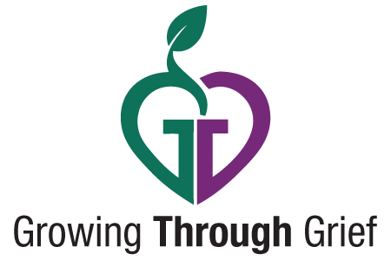
About Tomorrow is unique in that it focuses on the immediate needs of those in the first few months of loss. The honest and open conversations with real people are designed to help the listener understand that their feelings are normal, that others have shared the same thoughts and emotions, and that they will get better.

The CD was conceived by former Hollywood studio musician, Fred Frank, who says his motivation was the desire to help people “navigate their way through the dark emotional valley” of grief. Frank says he hopes About Tomorrow will “validate their feelings and show them that life will never be the same, but that it can be very, very good.”

The program has earned early praise from members of the professional grief resources community. Andrea Gambill, Editor of Grief Digest Magazine says the audio format makes sense. “Reading is good, but listening to this CD is much, much better! It’s like having an intimate group of precious friends always available in my home to comfort, support, encourage and love my broken heart.”

The 24 tracks on About Tomorrow provide first-hand insight and advice on a variety of topics including: Dealing with Friends Who Don’t Understand, Comforting Others Who Need Your Support, Taking Care of Unfinished Business, How Grief Can Challenge Your Faith, and many others. Each segment is packed full of unrehearsed and unscripted comments from “real people who’ve lost someone they love.”

About Tomorrow was written and produced by Steve Harris, a Southern California audio/video producer who lost his own wife to breast cancer just as the program was being planned. Julie’s death allowed Steve to discover for himself that “you can’t really understand what grief really feels like until you’ve gone through it yourself.” In the months that followed his wife’s passing, Steve interviewed more than twenty grieving people with varied backgrounds, beliefs, circumstances, and experiences. Those conversations not only became the centerpiece of the product, but a significant part of his own healing process.

The About Tomorrow CD is a product of Growing Through Grief, a division of Comfort Music, the leading innovator of unique musical concepts for the funeral service industry. Growing Through Grief has previously distributed a series of grief support CDs titled: Mending the Heartache with Faith, About Tomorrow and It Hurts to Say Goodbye. All three existing titles are being phased out as the new version comes to market.

About Tomorrow is available in bulk quantities through Vantage Sales in Nashville, TN. Organizations wishing to purchase wholesale can contact Flossi Goff at 615-324-8327. Individual copies can be ordered on-line at www.growingthroughgrief.com.

#30#

Enclosed:

Audio CD with sample packaging
Endorsement sheet
Additional story ideas

