CONTACT: Fred Frank
Box 3403
San Clemente, CA 92674
Phone 800-266-6876
fred@growingthroughgrief.com

Product Fact Sheet

Title: About Tomorrow: Mending the Heartache of Grief
Format: Audio CD
Length: 66 minutes
MSRP: $12.99
UPC: 8-9458900150-9
Number of people interviewed: 20+
Age range of people interviewed: Early 20s to late 70s
Song titles included:
  - With Hope
  - Written by Stephen Curtis Chapman
  - Performed by Jeff Gunn

  - The Ones Left Standing
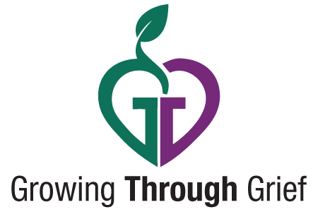
  - Written by Wayne Watson
  - Performed by John Barbour

Soundtrack composer: John Campbell
Writer and Producer: Steve Harris
Other projects Steve has produced:
  - Creator and original producer of Focus on the Family’s Adventures in Odyssey
  - Producer of The Alternative with Dr. Tony Evans
  - TV specials, education and inspiration audio and video programs
Product URL: www.growingthroughgrief.com
Sales:
  - The Vantage Group
  - 5585 Mountain View Road
  - Nashville, TN 37013
  - Flossi Goff - 615-324-8327

